Eclipse Hadoop2.x插件编译
- 下载hadoop2x-eclipse-plugin-master.zip，解压文件。
- Eclipse创建普通项目，如HadoopClient。
3、拷贝hadoop2x-eclipse-plugin-master的文件到项目中，如图所示：
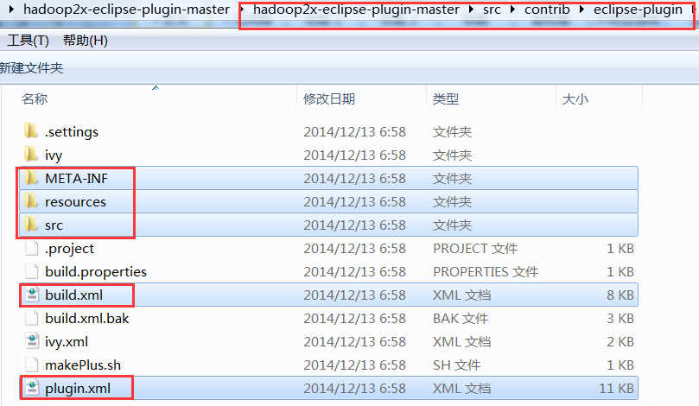

4、出错不要紧，之后打开build.xml文件，直接把如下代码贴进去覆盖原有的
<?xml version="1.0"?>
<project name="eclipse-plugin" default="jar">
<property name="jdk.home" value="I:/jdk1.8.0_102" />
<property name="hadoop.version" value="2.4.1" />
<property name="hadoop.home" value="J:/Development/Hadoop/src/hadoop-2.4.1" />
<property name="eclipse.version" value="4.6.2" />
<property name="eclipse.home" value="I:/eclipse-jee-neon-2-win32-x86_64/eclipse" />
<property name="root" value="${basedir}" />
<property file="${root}/build.properties" />
<property name="name" value="${ant.project.name}" />
<property name="src.dir" location="${root}/src/java" />
<property name="build.contrib.dir" location="${root}/build/contrib" />
<property name="build.dir" location="${build.contrib.dir}/${name}" />
<property name="build.classes" location="${build.dir}/classes" />
<!-- all jars together -->
<property name="javac.deprecation" value="off" />
<property name="javac.debug" value="on" />
<property name="build.encoding" value="ISO-8859-1" />
<path id="eclipse-sdk-jars">
<fileset dir="${eclipse.home}/plugins/">
<include name="org.eclipse.ui*.jar" />
<include name="org.eclipse.jdt*.jar" />
<include name="org.eclipse.core*.jar" />
<include name="org.eclipse.equinox*.jar" />
<include name="org.eclipse.debug*.jar" />
<include name="org.eclipse.osgi*.jar" />
<include name="org.eclipse.swt*.jar" />
<include name="org.eclipse.jface*.jar" />
<include name="org.eclipse.team.cvs.ssh2*.jar" />
<include name="com.jcraft.jsch*.jar" />
</fileset>
</path>
<target name="init" unless="skip.contrib">
<echo message="contrib: ${name}" />
<mkdir dir="${build.dir}" />
<mkdir dir="${build.classes}" />
<mkdir dir="${build.dir}/lib" />
<copy todir="${build.dir}/lib/" verbose="true">
<fileset dir="${hadoop.home}/share/hadoop/mapreduce">
<include name="hadoop*.jar" />
<exclude name="*test*" />
<exclude name="*example*" />
</fileset>
<fileset dir="${hadoop.home}/share/hadoop/common">
<include name="hadoop*.jar" />
<exclude name="*test*" />
<exclude name="*example*" />
</fileset>
<fileset dir="${hadoop.home}/share/hadoop/hdfs">
<include name="hadoop*.jar" />
<exclude name="*test*" />
<exclude name="*example*" />
</fileset>
<fileset dir="${hadoop.home}/share/hadoop/yarn">
<include name="hadoop*.jar" />
<exclude name="*test*" />
<exclude name="*example*" />
</fileset>
<fileset dir="${hadoop.home}/share/hadoop/common/lib">
<include name="protobuf-java-*.jar" />
<include name="log4j-*.jar" />
<include name="commons-cli-*.jar" />
<include name="commons-collections-*.jar" />
<include name="commons-configuration-*.jar" />
<include name="commons-lang-*.jar" />
<include name="jackson-core-asl-*.jar" />
<include name="jackson-mapper-asl-*.jar" />
<include name="slf4j-log4j12-*.jar" />
<include name="slf4j-api-*.jar" />
<include name="guava-*.jar" />
<include name="hadoop-annotations-*.jar" />
<include name="hadoop-auth-*.jar" />
<include name="commons-cli-*.jar" />
<include name="netty-*.jar" />
</fileset>
</copy>
</target>
<target name="compile" depends="init" unless="skip.contrib">
<echo message="contrib: ${name}" />
<javac fork="true" executable="${jdk.home}/bin/javac" encoding="${build.encoding}" srcdir="${src.dir}" includes="**/*.java" destdir="${build.classes}" debug="${javac.debug}" deprecation="${javac.deprecation}" includeantruntime="on">
<classpath refid="eclipse-sdk-jars" />
<classpath refid="project-jars" />
</javac>
</target>
<target name="jar" depends="compile" unless="skip.contrib">
<pathconvert property="mf.classpath" pathsep=",lib/">
<path refid="project-jars" />
<flattenmapper />
</pathconvert>
<jar jarfile="${build.dir}/hadoop-${hadoop.version}-eclipse-${eclipse.version}-plugin.jar" manifest="${root}/META-INF/MANIFEST.MF">
<manifest>
<attribute name="Bundle-ClassPath" value="classes/,lib/${mf.classpath}" />
</manifest>
<fileset dir="${build.dir}" includes="classes/ lib/" />
<fileset dir="${root}" includes="resources/ plugin.xml" />
</jar>
</target>
<target name="clean">
<echo message="contrib: ${name}" />
<delete dir="${build.dir}" />
</target>
</project>

<path id="project-jars">
<fileset file="${build.dir}/lib/*.jar" />
</path>

其中如下部分需要修改：
<property name="jdk.home" value="…" />
<property name="hadoop.home" value="…" />
<property name="eclipse.home" value="…" />
以下部分会拼接成版本的名字：
<property name="eclipse.version" value="4.6.2" />
<property name="hadoop.version" value="2.4.1" />

5、右键build.xml文件 ==》【Run AS】==》【Ant Build】
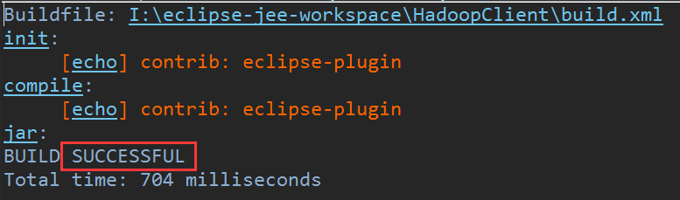
6、最后生成插件
